HARDWARE ARCHITECTURE SPECIFICATION

Integrated HUB V1.0

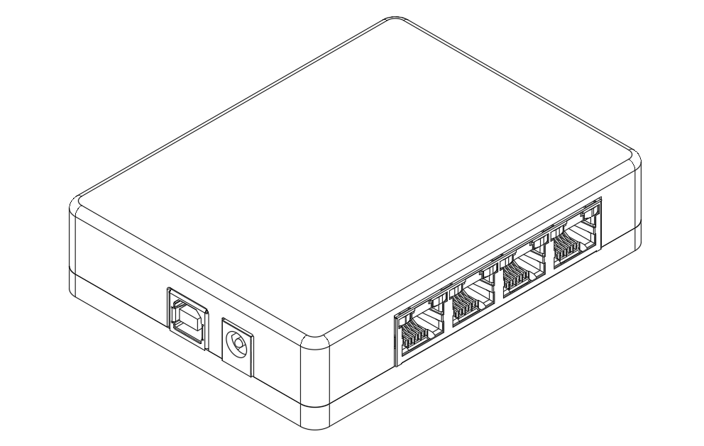
(insert image of project… this one was generated using autocad)

Developed By:
Jesse Farrell

Contact:
jessefarrell92@gmail.com
Contents
1. Product Brief 2
2. Introduction 2
2.1. Purpose 2
2.2. Scope 2
3. System Overview 2
3.1. Quick Start 2
3.2. Block Diagram 2
3.3. Intended Use Cases 2
4. Functional Requirements 2
4.1. Core Features 2
4.2. Constraints 2
5. Research & Development 2
5.1. Transformerless PHY Interface (Example) 2
6. Hardware Components 2
6.1. Bill of Materials 2
6.2. Mechanical Interfaces 2
6.3. Alternates 2
6.4. Variants 2
7. Performance Metrics 2
7.1. Power Consumption 2
7.2. Power Delivery 2
7.3. Reliability 2
8. Manufacturing 2
9. Conclusion 2
References 2
Appendix A - Errata 2
Appendix B – Schematic 2

Table of Figures
No table of figures entries found.
Revision History
Doc. Rev. | Release Date | Comments
0.0 | xxx | Initial beta pre-release.

Acronyms & Terminology
Examples…
C&C – Creepage and Clearance
DoC – Declaration of Conformity
DUT – Device Under Test
NIC – Network Interface Card
RS232 – Recommended Standard 232
USB – Universal Serail BUS

Product Brief
General high-level description of the product, elevator pitch style…
Example…
“The Integrated HUB is a multi-functional device that integrates several common USB dongles into one. This device integrates a USB to ethernet NIC, a USB HUB, a USB to RS232 converter, and an unmanaged network switch into a unified simple solution. The USB to ethernet adapter has a fixed connection to port 0 of the switch. Unlike many switches and USB HUBs on the market, this device does not require an external power brick.”

Introduction
FLUF

Purpose
Why this document exists and what it aims to achieve.
The following document outlines all traceability, specifications, and usability for the Integrated HUB project. The audience should be end users, designers looking to reproduce or mimic the project, and for myself if I need to revisit this design in the future.

Scope
Boundaries of the hardware architecture described (e.g., what is included or excluded)

System Overview
FLUF

Quick Start
General step by step guide for new users trying to use this product.

Block Diagram
Break out the fusion360… or paint!

Intended Use Cases
Recommended by ChatGPT, maybe remove.

Functional Requirements
FLUF

Core Features
Not requirements or specs. Overarching features we’re trying to/need to accomplish.

Constraints
Constraints under which we’d like to accomplish the above features.

Research & Development
Catch all section for relevant research and testing done during development of the product.

Transformerless PHY Interface (Example)

Hardware Components
FLUF

Bill of Materials
Self-explanatory… Include variants if applicable

Mechanical Interfaces
Mainly indented for projects with lots of user facing ports… likely none of my projects maybe scrap from template.

Alternates
Any and all critical alternates I designed into this project. Be sure to highlight what’s tested and what’s untested.

Variants
Variants of the project if they exist.

Performance Metrics
Any and all tests I’d like to have traceability on should be detailed here. Feel free to link to the design and test repo.

Power Consumption
Document the expected power consumption of the product.

Power Delivery
This can include PSU efficiency, and stability analysis. Expected product load is documented in “power consumption”.

Reliability
Any reliability data I have on the product. Why am I confident it won’t break.

Manufacturing
If someone wants to reproduce the project here’s what they need to know.

Conclusion
Closing comments for this project.

References
blah

Appendix A - Errata
Copy of the current errata for the most recent PCBA. Errata items should stay if the product is already released… just be sure to name the exact PCBA rev where the error occurred and where it was fixed.
I think maybe remove this…

Appendix B – Schematic

